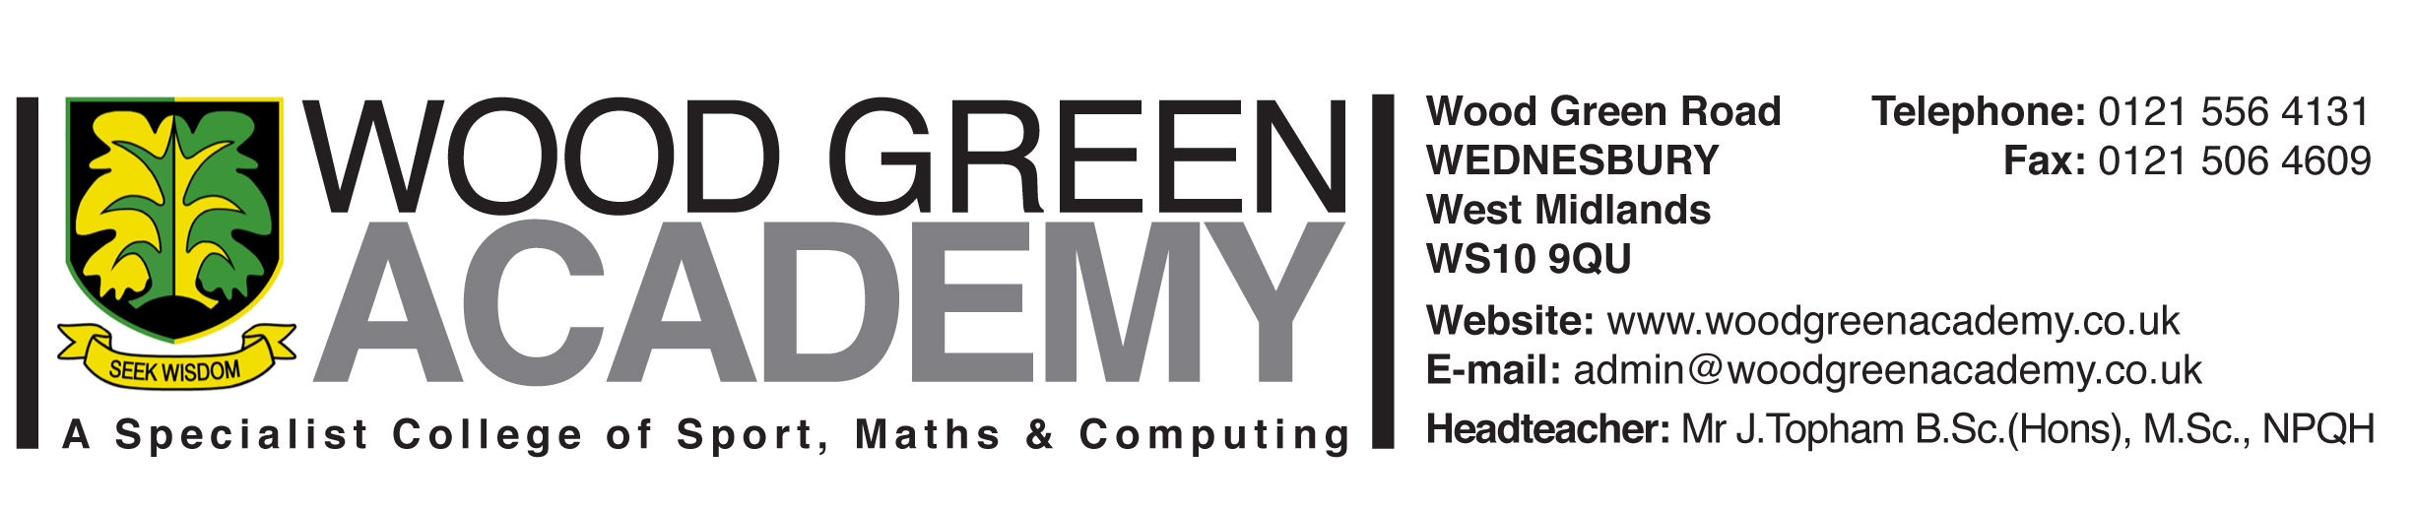

July 2025

Dear Parent /Guardian

**Work Experience Scheme**

**W/C Monday 20th – Friday 24th April 2026 (population 1)**

**W/C Monday 27th April to Friday 1st May 2026 (population 2)**

Our Work Experience Scheme in 2026 will involve your son/daughter undertaking a one-week work experience placement on one of the above dates in year 10. Work Experience takes a lot of organisation and I am sure you will appreciate the planning that it involves, thus we are preparing pupils in advance.

We hope that every pupil will take part and it is hoped that these placements will be regarded with importance as this is an excellent opportunity for your son/daughter to gain valuable employability skills and knowledge and an employer work reference for further studies/ UCAS / job applications.

All pupils are encouraged to find themselves a suitable placement to make the process similar to applying for a job and therefore realistic. Your son/daughter will also be offered help and support at lunchtimes drop-in sessions with myself in school, which will allow him/her to find and research suitable WEX placements.

Companies that we have used in the past will be available on a WEX spreadsheet on th**e student hub under Careers@WGA** for your son/daughter to research and to contact. We will try to keep this as up to date as we can, but it is not a guarantee that all companies will offer placements next year.

The attached (Company details forms) will need to be completed for the placement to be organised and confirmed, as all placements will need to be Risk Assessed before students will be allowed to go on their work experience. **Also, it is important that the placement has been agreed and signed by a member of the company, before the school makes contact**.

**For Health & Safety Verification of the placement, we will need a copy of the Employer’s Liability Insurance (ELI). Without ELI the placement cannot be approved.**

Also please be aware that many Primary Schools will **NOT** offer placements to ex-pupils, or where siblings attend and this must be taken into consideration when making decisions about Work Experience choices.

The school reserves the right to NOT offer Work Experience in the case of poor attendance or unreasonable behaviour.

**The deadline** for the completed Company details forms to be handed in is **Friday 11th December 2025 to your son/daughter’s form tutor.**

Yours faithfully

Miss A. Birch

Careers Leader